**Continuous System Simulation**

**Chapter 3**

**Compiled By: Bal Krishna Nyaupane** [**balkrishnanyaupane@gmail.com**](mailto:balkrishnanyaupane@gmail.com)

# 3.1 Continuous system simulation

* In a model for a continuous system the relationship describes the rate at which the variables representing the attributes change and hence the model consist of differential equations.
* The simplest differential equation models have one or more linear differential equations with constant coefficient.
* Non-linear ties are introduced either if any of the derivatives of independent variables are raised to power greater than one or all combined in any other way, say being multiplied together.
* If more than one dependent variables occurs in a differential equation, it is said to be partial differential equation.
* Both linear and non-linear types of differential equations occur in scientific and engineering studies. For solving such equation numerical methods are largely applied specially when the equation is of higher order or non-linearity exists in them. So simulation can be developed by showing their application to models where the differential equations are linear and have constant coefficients, and then generalizing to more complex equations.
* When more than one independent variable occurs in a differential equation, the equation is said to be partial differential equation. It can involve the derivation of the same dependent variable with respect to each of the independent variables. It can involve the derivatives of the same dependent variable with respect to each of the independent variable.
* Example, An equation describing the flow of heat in a three dimensional body. There are four independent variables, representing the three dimensions and time and one dependent variable, representing temperature.
* Differential equations occur repeatedly in scientific and engineering studies. The most physical and chemical processes involve rate of change, which requires differential equations for their mathematical descriptions.
* Since a differential coefficient can also represent a growth rate, continuous models can also be applied to problems of a social or economic nature where there is need to understand the general effects of growth trends.
* To illustrate how differential equations can represent engineering problems we will show how the equation describing the automobile wheel suspension system is derived from mechanical principles. 3
* The differential equations describing automobile wheel suspension system, M𝑥¨ +D𝑥˙+K𝑥=kF (t)… (1)

𝑥¨ -Acceleration of wheel

𝑥˙- Velocity of wheel

𝑥 −Displacement of point

* The equation of motion in the absence of other forces:

M𝑥¨ = k F (t)

* The shock absorber exerts a resisting force that depends or the velocity,

D𝑥˙-Directly proportional to the velocity

* If the force is directly proportional to the compression, it can be represented by,

𝑘𝑥

* Since both these force oppose the motion, so

𝑀𝑥¨ =𝑘𝑓 − 𝐷𝑥˙ − 𝑘𝑥 ……………..(2) 4

𝑡

* It is a combination of device specified by mathematical model of system which is used for system simulation. It gives continuous output hence used for continuous system simulation. When they are primarily used for differential models, they are called differential analyzer.
* Simulation with an analog computer is more properly described as being based on a mathematical model than as being a physical model.
* The most widely used from of analog computer is the electronic analog computer called operational amplifiers. Voltage in the computers are equated to mathematical variables, and the operational amplifiers can be add and integrate the voltage.
* With the help of appropriate circuit, operational amplifier can be used as *summers, integrator, and sign inverter*.
* In integrator, the output is the integral with respect to time of a single input voltage or the sum of several input voltages.
* *Sign inverter* which is designed to cause the output to reverse the sign of the input.

### Limitation of Analog Computer

* + Difficulty to carry the accuracy of measuring a voltage beyond a certain point.
  + A number of assumptions are made.
  + Do not solve the mathematical model with complete accuracy.(Should be zero output for zero input )
  + Difficulty to maintain accuracy better than 0.1%.
  + Operational amplifiers have a limited dynamic range of output so that a scale factor must be introduced to keep within the range.

### Advantages of Analog Computer

* + An analog computer must usually be dedicated to one application at a time.
  + The analog representation of a system is often more natural in the sense that it directly reflects the structure of the system.
  + Under certain circumstances, an analog computer is faster than a digital computer

### Digital computer

* + Virtually any degree of accuracy can be programmed
  + With the use of floating point representation of numbers an extremely wide range of variations can be tolerated.
  + Easy to use for many different problems.
  + A digital computer can be working only on one equation at a time giving the appearance of simultaneity by interlacing the equations.
  + A digital computer has the advantage of being easily used for many different problems.
* The general method by which analog computers are applied can be demonstrated by using the second order differential equations.
* With an electronic analog computer the variables that have been described would be voltages and the symbols would represent operational amplifiers arranged as adder’s , integrators and any sigh changers.
* There can be several ways of drawing a diagram for a particular problem depending upon which variable are of interest and on the size of the scale factor.
* When a model has more than one independent variable a separate block diagrams drawn for each independent variable and where necessary interconnections are made between the diagrams.

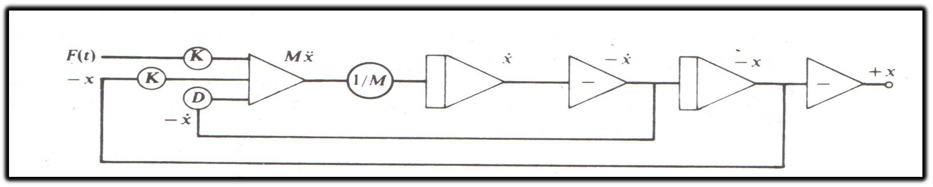

Figure: Diagram for automobile suspension problem.

* The general method by which analog computers are applied can be demonstrated using the second—order differential and solving the equation for the highest order derivative gives

𝑀𝑥¨ +𝐷𝑥˙+𝑘𝑥 = 𝑘𝑓(𝑡)

𝑀𝑥¨ = 𝑘𝑓(𝑡)‐ 𝐷𝑥˙‐𝑘𝑥……………(1)

* Summer takes three variables as input f(t)- 𝑥˙ and –𝑥 and these three variables can scaled and added with a summer to produce a voltage representing 𝑀𝑥¨ . Integrating this variable (𝑀𝑥¨ ) with a scale factor of 1/M produces 𝑥˙ . Sign inverter produces -𝑥˙; and a further integration produces -𝑥˙. A further sign inverter is included to provide + 𝑥 as output.
* The symbols used in the figures are standard symbols. The circle indicates scale factors applied to the variables. The triangle symbol at the left of the figure represents the operation of adding variables. The triangle symbol with a vertical bar represents an integrator, and the one containing a minus sign is a sign changer.
* The addition on the left, with its associated scaling factors, corresponds to the addition of the variables representing the three forces on the wheel, producing a variable representing M .
* The scale is changed to produce 𝑥¨ and the result is integrated twice to produce both 𝑥˙ and x.
* Sign changers are introduced so that variables of the correct sign can be fed back to the adder, and the output can be given in convenient form.
* With an electronic analog computer, the variables that have been described would be voltages, and the symbols would represent operational amplifiers arranged as adders, integrators, and sign changers.
* The compartments 1, 2 and 3 represents the blood vessels, the liver, and the bile respectively.
* 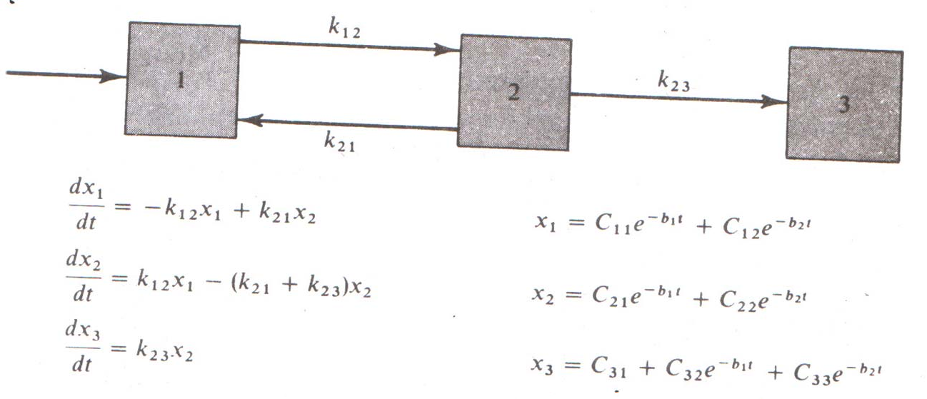The Mathematical model of the Liver:

11

* There are three integrators. Reading from left to right, they solve the equation x1, x2, x3. Interconnections between the three integrators, with sign changers where necessary, provide inputs that define the differential coefficients of the three variables.
* The symbols used in the figures are standard symbols. The circle indicates scale factors applied to the variables. The triangle symbol with a vertical bar represents an integrator, and the one containing a minus sign is a sign changer.

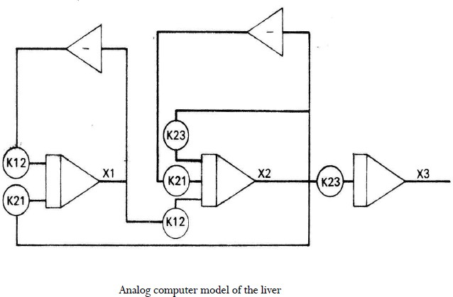

12

# Hybrid Computer

* It has come to describe combinations of traditional analog computer elements, giving smooth continuous outputs and elements carrying out such nonlinear digital operations as storing values switching and performing logical operations.
* Hybrid computer may be used to simulate systems that are mainly continuous but do have some digital elements. Example artificial satellite for which both the continuous equation of motion and digital control signals must be simulated.
* The general technique of applying hybrid computers follows the method of computer with blocks in the diagrams representing the non-linear elements as special functions rather than as purely mathematical operators.
* Hybrid computers are useful when a system that can be adequately represented by an analog computer model is the subject of representative study.
* Hybrid computer can be arranged to carry out large portions of the study without human interactions.

# Digital Analog Simulators

* To avoid the disadvantage of analog computers, many digital computer programming languages have been written to produce digital analog simulators. They allow a continuous model to be programmed on a digital computer in essentially the same way as it is solved on an analog computer.
* The languages contain micro-instructions that carry out the action of adders, integrators and sign changers.
* A program is written to link together these macro instructions in essentially the same manner as operational amplifiers are connected in analog computers.
* More powerful technique of applying digital computers to the simulations of continuous system have been developed. As a result digital analog simulator are not in extensive use.

# Hybrid Simulation

* + An analog and digital computer are combined to provide a hybrid simulation depends upon the application. It uses of an analog or a digital computer for system simulation depends on the model (continuous or discrete).
  + The system being simulated is an interconnection of continuous and discrete subsystem, which can best be modeled by an analog and digital computer being linked together.
  + High speed converters are needed to transform signals form one form of representation to the other. Hybrid simulation is generally reserved for the case in which functionally distinct analog and digital computers are linked together for the purpose of simulation example use of digital elements added to the operational amplifiers of an analog computer.

## Continuous system simulation languages (CSSLs)

* Digital- analog simulators have restrictions on representing the functions of an analog or hybrid computers. Continuous system simulation languages overcome these restrictions. It uses statement type of input for digital computer.
* CSSLs allow a problem to be programmed directly from the equations of a mathematical model rather than requiring the equation to be broken into functional elements. CSSLs include macros or subroutine that perform the function of specific analog elements. It allow the users to define special purpose elements that correspond to operations that are particularly important in specific type of applications.
* CSSLs include variety of algebraic and logical expression to describe the relations between variables. CSSLs remove the orientation toward linear differential equations which characterizes analog methods.

### CSMP-III

* Continuous system modeling program version III
* A type of CSSLs.
* It is constructed from three general type of statement

## 3.8 Continuous system simulation languages (CSSLs)

### Structural Statement

* + Define the model
  + Consist of statements and functional blocks designed for operations that frequently occur in a model definition.
  + Use the operations of addition, subtraction, multiplication, division or exponentiation.
  + Example X=6.0*y/w+(Z-2.0)**2.0
  + They consist of FORTAM like statements.

### Data Statements

* + Assign numerical values to parameters constant and initial conditions.
  + Example: Const B=0.2, C=0.5 PARAM A= (0.1, 0.2, 0.3, 0.4)

### Control Statement

* + Specify options in the assembly and execution of the program and the choice of output
  + Example ENDJOB End of all runs

TIMER Specify certain time interval

* Feedback is used to describe a coupling between the input and output of the system. A significant factor in the performance of many systems. Example A home heating system controlled by a thermostat (Dependency upon temp).
* An example of continuous system control mechanism using feedback is aircraft system. Input is a desired aircraft heading and the output is the actual heading. Gyroscope of the autopilot is able to detect the difference between the two headings. A feedback is established by using the difference to operate control surface. The difference between the desired heading ϴi and actual heading ϴ0 is called the error signal ‘E’.
* Suppose the control surface angle is made directly proportional to the error signal the force changing the heading is then proportional to the error and it diminishes the aircraft approaches the correct heading.
* When the aircraft receipt a signal to change direction control surface angle (error signals) takes non-zero value. The aircraft heading respond to the control surface by moving toward the new heading but, because of inertia it takes time to respond.
* As the aircraft turns, the control surface angle decrease so that less force is applied as the aircraft approaches the required heading. When the aircraft reaches the required heading the control surface angle will be zero but inertia of the aircraft can carry it beyond the desired heading. So the control surface turns in the opposite direction in order to bring the aircraft back from its overshoot. The correction form overshoot produces and undershoot and the motion follows a series of oscillations of decreasing amplitude.
* The feedback in the autopilot system is negative feedback where the system output deviation from the desired output tends to decrease the input to drive system back. In positive feedback system the system output deviation from the desired output tends to increase the input level. Any prolonged positive feedback will make a system unstable.

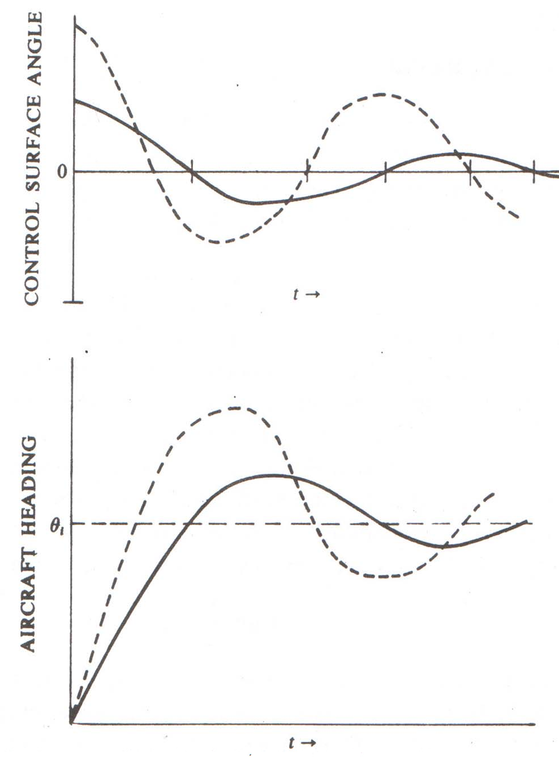

Figure: Aircraft response to autopilot system

Thank You

???